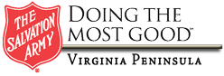
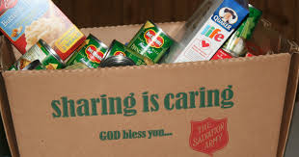

WILL YOU HELP PROVIDE A THANKSGIVING / CHRISTMAS MEAL FOR THOSE FAMILIES WHO’S INCOME FALLS BELOW THE FEDERAL POVERITY GUIDELINES?

OUR ANNUAL HOLIDAY FOOD DRIVE WILL BEGIN OCTOBER 28, 2019 THROUGH DECEMBER 09, 2019.

THE DROP OFF LOCATION IS:
1033 BIG BETHEL ROAD HAMPTON VIRGINIA 23666

Your assistance is greatly appreciated.

Applesauce (cups & jars) Ketchup
A cash donation is always welcome in place of purchasing food.
Or
Food Gift Cards will work as well.

Baked Beans (regular) Macaroni & Cheese
Baked Beans (vegetarian) Molasses
Brown Sugar Oat Meal (plan & flavored)
Cranberry Sauce Olives
Canned Fruit (variety) Pickles
Canned Condensed Milk Potato Flakes
Canned Sweet Potatoes Potato Chips (variety)
Canned Vegetables (variety) Pudding (variety)
Cereal (variety) Raisins
Crackers (variety) Rice
Fruit Snacks (variety) Sloppy Joe Mix
Gravy (jar, can, packet) Soup (variety)
Jelly (variety) Spaghetti / Pasta (variety)
Jiffy Corn Bread Mix Spaghetti Sauce
Juice Box Stuffing Mix
Should you have any questions, you can call Jim Colston at 757.838.4875 EXT 104.
Or email him at jim.colston@uss.salvationarmy.org.

